Starter Reading – The story of Sadako Sasaki

Who was Sadako Sasaki?
Sadako Sasaki (佐々木 禎子 Sasaki Sadako) (January 7, 1943 – October 25, 1955) was a Japanese girl who was two years old when the nuclear bomb was used on Hiroshima on August 6, 1945. Still today, nearly 60 years after her death, she is remembered as a symbol of the innocent victims of war, and particularly of the atomic weapon.

What happened to her?
Sadako was at her home near the Misasa Bridge when the explosion occurred, about 1.6 kilometres (0.99 mi) away from the centre of the blast. She was blown out of the window. Her mother ran out to find her, suspecting she may be dead, but found her two-year-old daughter alive.
In November 1954, Sadako developed swellings on her neck and behind her ears. In January 1955, purple spots had formed on her legs. She was diagnosed with leukaemia, hospitalized on February 21, 1955, and given, at most, a year to live.
Several years after the atomic bomb, an increase in leukemia was observed especially among children. By the early 1950s it was clear that the leukemia was caused by having been exposed to radiation from the nuclear bomb.

Why paper cranes?
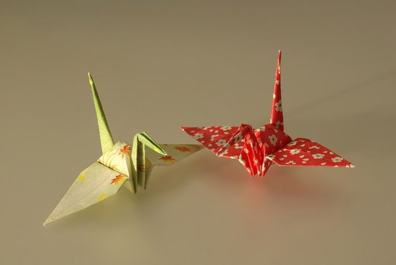
On August 3, 1955, Sadako's best friend Chizuko Hamamoto came to the hospital to visit, cut a gold piece of paper into a square, and folded it into a paper crane. Ancient Japanese mythology promised that anyone who folded one thousand origami paper cranes would be granted a wish by the gods. Though she had plenty of free time during her days in the hospital to fold the cranes, she lacked paper. Sadako used medicine wrappings and whatever else she could scrounge up. This included going to other patients' rooms to ask to use the paper from their get-well presents. Chizuko brought paper from school for Sadako to use.
A popular version of the story is that Sadako fell short of her goal of folding 1,000 cranes, having folded only 644 before her death, and that her friends completed the 1,000 and buried them all with her. An exhibit which appeared in the Hiroshima Peace Memorial Museum stated that by the end of August 1955, Sadako had achieved her goal and continued to fold even more cranes before her death.

During her time in the hospital her condition progressively worsened. Around mid-October her left leg became swollen and turned purple. With her family around her, Sadako died on the morning of October 25, 1955 at the age of 12.

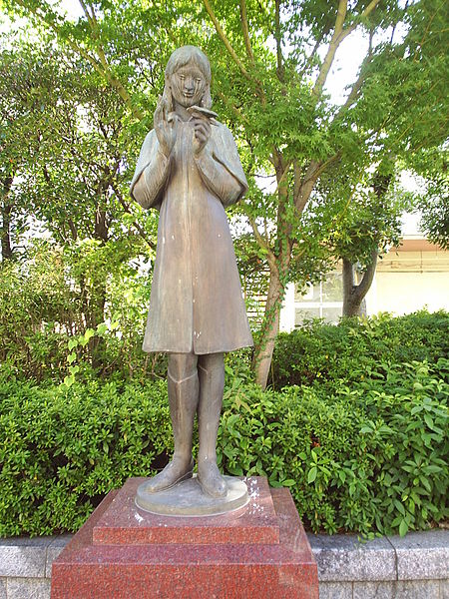
In memory of Sadako
After her death, Sadako's friends and schoolmates published a collection of letters in order to raise funds to build a memorial to her and all of the children who had died from the effects of the atomic bomb. In 1958, a statue of Sadako was placed in the Hiroshima Peace Park. It reads: "This is our cry. This is our prayer. Peace in the world."
Cranes, and the folding of cranes, have become leading symbols of the impact of nuclear war, and its appalling, and long-lasting, humanitarian consequences. Each year Japanese people mark August 6 as an annual day for peace, and re-tell the story of Sadako.

