**Starter Reading – Tracing: the beginnings**

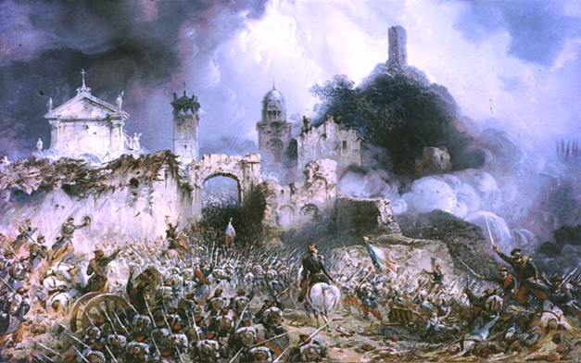As a young Swiss banker Henry Dunant wandered through the rows of dead and wounded at the Battle of Solferino in Italy in 1859 he was sickened by the stench, the horror of the wounds and the appalling lack of medical care. In particular, the plight of one victim affected him. Here is Dunant’s account of their meeting, from his diary ‘A Memory of Solferino’.

***‘A young [French] Corporal named Claudius Mazuet, some twenty years old, and with gentle expressive features, had a bullet in his left side. There was no hope for him, and of this he was fully aware. When I had helped him to drink he thanked me, and added with tears in his eyes, ‘Oh Sir, if you could write to my father to comfort my mother!’ I noted his parents’ address and a moment later he had ceased to live.’***

Henry Dunant never forgot the Corporal’s last request. He returned to Geneva and immediately started developing what would later become the Red Cross Movement. Dunant **located Mazuet’s parents** in Lyon and **delivered the news of their only son**. Up until that point, they had received no information and his name had been listed amongst the thousands of ‘missing’. Although the news was tragic, Durant was able to bring certainty and the opportunity for the family to begin to grieve. In doing so, Dunant enacted the **first Red Cross 'trace'.**

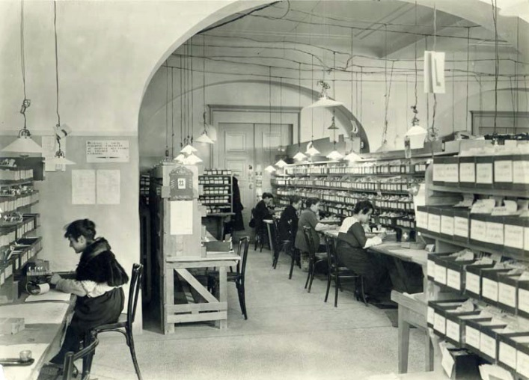The story of the **International Red Cross Central Tracing Agency in Geneva begins in 1870** during the Franco-Prussian War. By then the Red Cross had become an established and respected international organisation and Dunant’s principles had been incorporated into the First Geneva Convention to protect wounded and sick soldiers. Red Cross had set up a medical

headquarters in the neutral Swiss border town of Basle. A doctor, **concerned about the recovery of his patients**, found that one of their greatest worries was that family at home did not know whether they had been killed, wounded or taken prisoner. He felt that their morale would be significantly lifted if they were able to **send letters to their families**. On this advice, the Red Cross set up a small agency, on neutral Swiss territory, and began to work as an intermediary, passing on records of who was in their care, and negotiating delivery of patients’ personal letters.

Soon the Basle agency was going even further: providing a courier service and lists of those that had been taken prisoner, on both sides of the conflict. To ensure co-operation from all parties it was crucial that letters were of **a personal nature** **only** and that no sensitive military information be passed across the lines. This **commitment to Neutrality** is essential to the continued operations of the Red Cross and its status as a trusted humanitarian organisation.

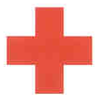

  **PRUSSIA**

The Red Cross successfully provided this service again during the Russo-Turkish War of 1877 and it has been a core role of the **International Committee of the Red Cross (ICRC)** ever since.

The rights of families are enshrined in the Geneva Conventions. The overall aim is to maintain some standards of humanity, even in war, and to ease the pain of separation. Some of the relevant legal provisions are as follows.

* ***‘The High Contracting Parties [to the Geneva Conventions] shall honour the right of families to know the fate of their relatives.’ (GC1, Art 25)***
* ***‘All persons…shall be enabled to give news of a strictly personal nature to members of their families, wherever they may be, and to received news from them’***

***(Additional Protocol 1, Art. 32)***

* ***‘Children shall be provided with the care and aid they require, and …[all appropriate steps] shall be taken to facilitate the reunion of families temporarily separated.’ (GC4, Art 25)***

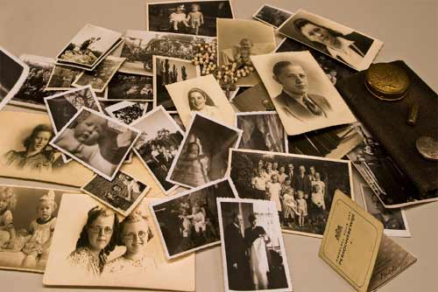 [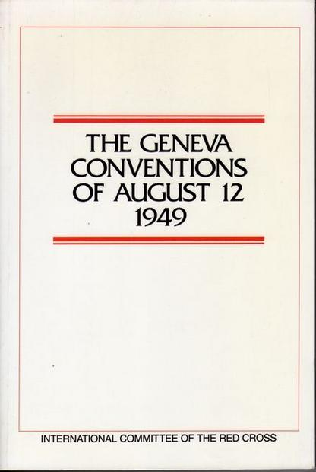](http://www.google.com.au/url?sa=i&rct=j&q=&esrc=s&frm=1&source=images&cd=&cad=rja&uact=8&docid=FqlqobNHAHnONM&tbnid=LwYFWYcBz1pjBM:&ved=0CAUQjRw&url=http%3A%2F%2Fdigitaljournal.com%2Farticle%2F277488&ei=kFdCU6eQMIPBkgWo5IGoAg&bvm=bv.64125504,d.dGI&psig=AFQjCNEPMbs7ch9irf41Lt95_pDmZq9Afw&ust=1396943072266939) 