Starter Reading – Samuel

Violence in Sierra Leone saw Samuel* separated from his two young children in 1999. After 13 years, he was able to be reunited with his son and daughter with help from Red Cross.

*Name has been changed to protect the privacy of the individual.

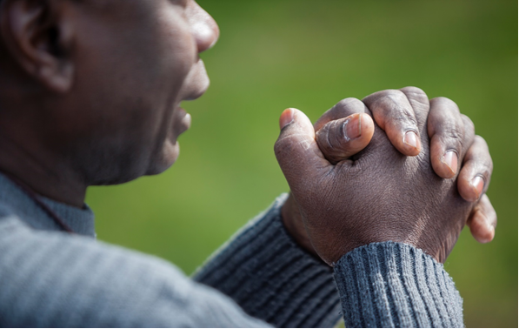

One person’s story

On 5th January 1999 Samuel left his home and two children to work in the nearby city of Freetown, in Sierra Leone. During his shift violence erupted in Freetown, and the hospital where he worked was attacked.

Samuel was unable to return home because of a siege and the escalating violence. He fled to nearby Ghana. Little could he have known that he would spend the next seven years in a refugee camp in Ghana, and during all this time, lose contact with his children. ‘All my thoughts were about my kids,” he said. Despite his many efforts, he was unable to get any news of their whereabouts or wellbeing.

Finally Samuel received a visa to come to Australia. Samuel approached the Australian Red Cross Tracing Service to help find his children. He wrote a Red Cross message, which Australian Red Cross sent to Sierra Leone Red Cross. Through its local networks the Red Cross there found his two children, who were now aged sixteen and seventeen.

Can you imagine how emotional he was? For the first time in many years, Samuel was able to contact his children directly and know they were safe. “Nobody slept that night,” he told Australian Red Cross. “We were just talking,” he said. “They were crying and talking”. They had been separated for thirteen years.

Australian Red Cross’ Tracing Service sends Red Cross messages on behalf of family members separated by conflict, disaster and migration. Red Cross messages are short letters used by Red Cross to share family news, when there is no other means of making contact with loved ones. Most often this is during armed conflict or other situations of violence, and during natural disasters.

Australian Red Cross’ International Tracing Service has recently broadened its Tracing criteria to accept cases where loss of contact has occurred as a result of migration.

It does not take on cases of adoption where people are searching for their birth mothers, nor of missing runaways. These are the work of other agencies. Red Cross’ unique advantage and expertise are in making use of its broad international networks – that is, its colleagues in the 189* Red Cross and Red Crescent National Societies around the world. (*figure current at April 2014)

