**Explore – Research, think, do**

**Exploration 1 – Australian Red Cross Tracing in World War 1**

**Choose one of the following topics to follow up further.**

**An exceptional Red Cross woman**

* Red Cross provided Vera Deakin with incredible opportunities to contribute to the war effort. What was it about this woman that inspired her to travel half way around the world in 1915? Explore **her role at the Enquiry Bureau** more fully, and follow the story of this exceptional woman further after World War 1. She was once again heavily involved with **Tracing during World War 2**: What were the different issues of Tracing in that conflict? Describe her ongoing work and commitment to Australian Red Cross until her death in 1978.
* **Write a brief report.**

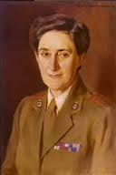 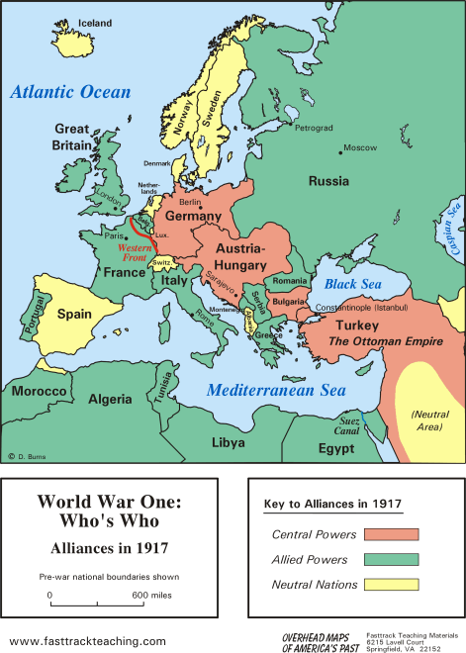

Portrait of Mrs Vera White OBE The powers and alliances of WW1

(nee Vera Deakin) by Robert Hofmann

AWM collection, P02119.002

**Long before emails and mobiles!**

* What **types of communications** would Red Cross have used to conduct Tracing in 1914-1918?
* How long might news have taken to reach Australia from the front lines in France? If unsure, how would you find out?
* A successful Tracing Services requires **effective communication across borders**. During World War 1, which other National Red Cross or Red Crescent Societies do you think Australian Red Cross would have needed to work with closely?
* **Research these areas and compile a summary.**

**Searchers**

* **You are a ‘searcher’ for Australian Red Cross.** **‘Feel’ your way** into this person’s experience by thinking about these points.
* Searching is a tough and sobering job – dealing with sad stories of young lives lost every day. **What inspired you to volunteer** for this role? Why do you think it is so important?
* What do you think are the most important **personal qualities needed** for the job? How do you keep going? Does the weight of responsibility burden you?
* How do you travel back and forth on the frontline to find your witnesses?
* How do requests come to you from the Enquiry Bureau, and how do you relay your findings back to Vera Deakin and her staff in London?
* Is it easy to get information about soldiers’ deaths wrong? How can this happen? What checks and double-checks do you use?

* What are **‘dog-tags’**? What information is etched on them? How important are they for you? (Read what the First Geneva Convention says about identity discs and how they should be used on the battlefield. Try to find an image of Australian discs – or perhaps you even know a member of the Australian Defence Force who can show you his/her tags.)

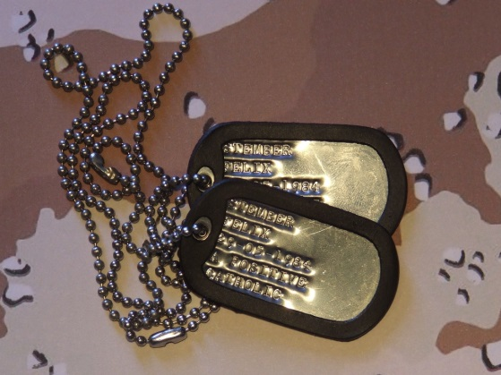 Pictorial only.

* **Using these thoughts and ideas, and your own reading about searchers, your actual task is to:**

**Produce a coloured poster advertising for searchers** to work for Australian Red Cross in 1916.

**Tips:**

* 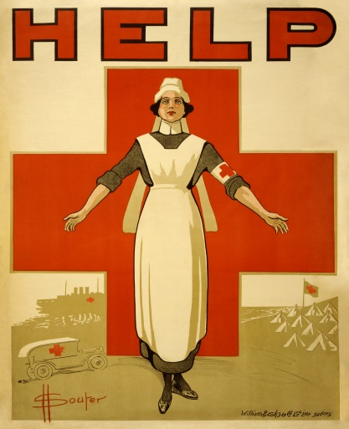Make it as authentic as you can for the ‘look’ of the times. There are some **iconic Red Cross recruitment posters** from World Wars 1 & 2. Cruising through some of them may give your inspiration.
* Appeal for people who feel strongly committed to the work as a humanitarian task.
* The poster should show an understanding of the searchers’ job and direct people where to apply.

WW1 poster by David Souter