**Explore – Research, think, do**

**Exploration 2 – Australian Red Cross Tracing today**

* The suggestion for teachers is to move quite fast through Tasks 1-4, allowing 5 minutes each to **gather and discuss class responses**.
* Tasks 5 – 6 encourage students to act as the Red Cross Tracing worker, and to **think logically and creatively, like a detective!**
* Task 7 prompts students to **empathise with Tracing clients and ‘feel’ their way into their lives, relationships and needs.**

**Task 1**

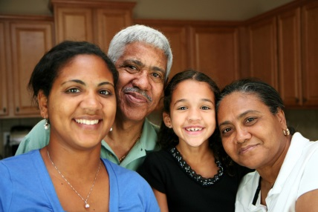The rights of families are protected under the Geneva Conventions (International Humanitarian Law or IHL). Why is the **concept of family so important in our society**? What are the benefits - to the individual, the family, the community and the government – of ensuring that families can remain connected?

**Task 2**

In times of war, **separation of families happens so easily**. Why is this? As a group, make a list of all the factors – social, political, economic, military etc.

**Task 3**

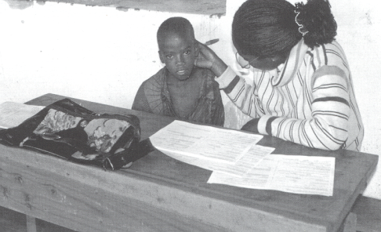The **tracing of children** is a high priority. What are some reasons it is especially difficult?

**Task 4**

Australian Red Cross’ Tracing cases concern:

1. People who have fled, or who remain in, **conflict zones around the world**; and
2. People caught up in **natural disasters**

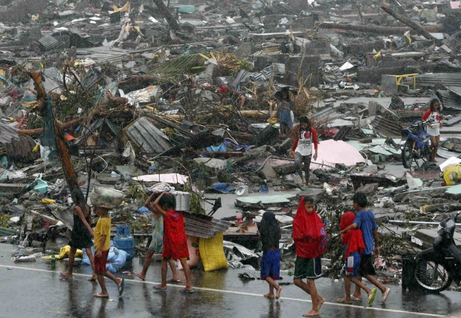 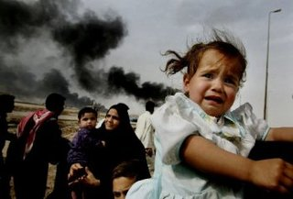

* Buzz around the class, listing countries which are/have experienced armed conflict, and major international and national natural disasters for which Tracing may have been involved. Set the class a target to reach.
* **Work in the period from 2000 to 2014.**

**Task 5**

* Use [www.restoringfamilylinks.org](http://www.restoringfamilylinks.org) to help complete the case study tasks below.

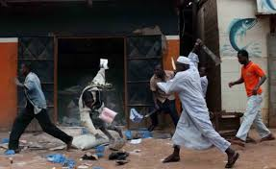

You fled your home country because of an uprising and fear of persecution by current government forces. You have had no contact with your family since then in order to avoid difficulties for them. After years in a refugee camp in a neighbouring country, you are granted a visa to Australia and now reside in the community. As time passes you decide to send a Red Cross message to your family, letting them know you are safe and to find out their circumstances too.

* Study the current **Australian** **Red Cross message form** (available under Exploration 2).
* What limitations are there on the content and delivery of a Red Cross message for each of the following?
* for the enquirer
* the sought persons
* the government/military
* the Red Cross fieldworker
* What security issues could be involved for each of the groups?
* You have lived for several decades under a very strict and punitive government, a **dictatorship which allowed no political opposition** and few freedoms. It is finally overthrown. However, in seeking to find missing family members, you are still reluctant to fill out Red Cross tracing forms. Why might this be?
* Which of the **Red Cross Fundamental Principles** (code, values) are crucial to ensure the safety, trust and co-operation of all the parties?

**HUMANITY  
IMPARTIALITY  
NEUTRALITY  
INDEPENDENCE  
VOLUNTARY SERVICE  
UNITY  
UNIVERSALITY**

* There are times in disaster or conflict situations where infrastructure is damaged or inaccessible so paper Red Cross message forms are still necessary. However, technological advances have helped Tracing Departments enormously since the days of paper. What are some of the **advantages that new technology** would have brought for all involved in Tracing?

**Task 6**

Australian Red Cross receives enquiries from overseas Red Cross National Societies on behalf of people searching for family members in Australia. Read the hypothetical tracing case below and assess it as an Australian Red Cross Tracing Officer.

In 2002 the Australian Red Cross received a tracing request from the Polish Red Cross. The enquirer Ada, an elderly female, was looking for her brother Piotr whom she had not seen for 52 years. World War 2 had produced a large number of refugees, and many families, such as this one, had lost contact with each other.

Ada, had previously opened Tracing enquiries with the American and the Russian Red Cross Societies, based on information she had, but despite extensive searches the outcome was not successful.

In 2002, after conducting her own research, Ada received news from National Archives Australia that a man matching her brother’s name and age had migrated to Australia in the 1950s and seemed to have settled in Western Australia. The National Archive documentation indicated Piotr’s occupation was a carpenter. At the time this man was about to travel to Australia, he had been engaged to be married.

MC900355945[1]

* **Follow the trail as a Tracing worker would**.
* Assess the information given. Which details about Ada and her brother Piotr are especially significant?
* What further information would be useful to know about Piotr, to help get a better idea about where he could be? **Where would you begin your search for Piotr**?

Here are potential search avenues. Which ones would you use in this enquiry? Why?

* White Pages
* Australian government agencies
* Embassies
* Births, deaths and marriage registry
* Social media sites

Apart from those official search avenues listed, community specific searches are a vital source of information. How would you search and communicate with the local Polish community?

**Task 7 - Put yourself into his shoes**

* You are Samuel. ‘Feel’ your way into his experience and his emotions, using the prompts below.
* How would you have felt as you left Sierra Leone? About your own family? About the future of your country?

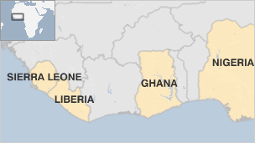

* How far is it to Ghana? How did you get there? What were the **greatest dangers on the way**?
* Do you have identification or any official papers with you? If not, why not? What issues will this cause you? How much did you carry as you fled? Why?
* **What language** do you speak? Can you read?
* What were your seven years in Ghana like? How did you spend most of your time in the camp? Did you have money?
* Why didn’t you get into contact with your children from Ghana?
* How does it feel when you arrive in Australia? What is wonderful about it? What is your worst fear? Are you **made to feel welcome**? Who by?
* How do you feel before the **first phone call arranged by the Tracing team**? You haven’t heard of them for so long – they are strangers. Will they even remember you?
* And afterwards? Was it really all excitement and joy: what else tinged the conversation?
* Will your children want to come to live in Australia? If and when peace is restored in Sierra Leone, will you want to return home? Why or why not?

Using this information, and other reading:

**Create a poster advertising the work of Australian Red Cross Tracing Service** to a multicultural audience.

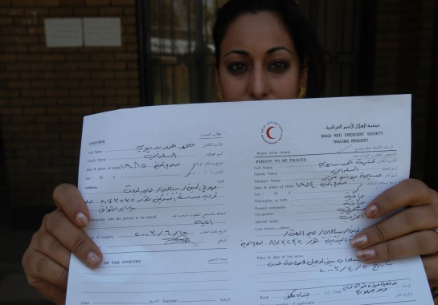 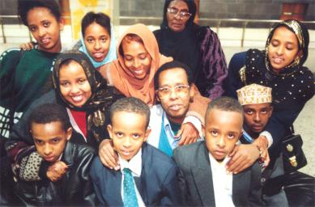

**Tips:**

* + - In quite limited words it needs to highlight its work reconnecting separated family members.
    - Emphasize Red Cross’ Principles – working for **humanity, across all nationalities, religions, politics.**
    - Make it **inviting and reassuring** for people who are anxious. Will your poster be in English or another language?
    - [Google Images](https://www.google.com.au/imghp?hl=en&tab=wi&ei=-XdDU4m5G4H_8QXK-YHYAw&ved=0CAQQqi4oAg) may be useful for a collage effect.